Application Form
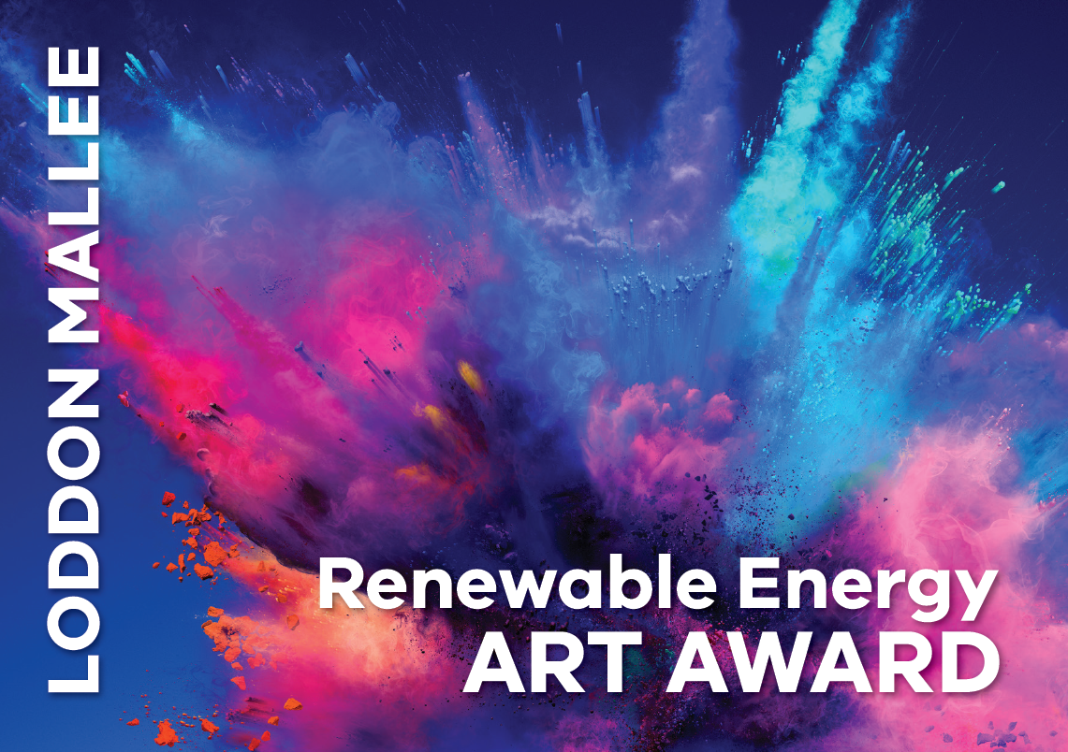
Theme: “Our renewable energy future”
Email completed form to artsaward@cvga.org.au, you will receive confirmation of receipt, deadline for entries is midnight, Sunday 25 August
Applicant Details
Name:
Address:
Phone number:
Municipality:
Name of legal guardian if applicant under 18 years of age:
__________________________________________________
Signature of legal guardian if applicant under 18 years of age:
____________________________________________________

Application Questions
1. Describe your proposed artwork in 150 words or less (it is understood that the concept may evolve over the course of producing it)

2. Describe how your artwork will respond to the theme in 250 words or less

3. Describe your art making experience in 250 words or less

