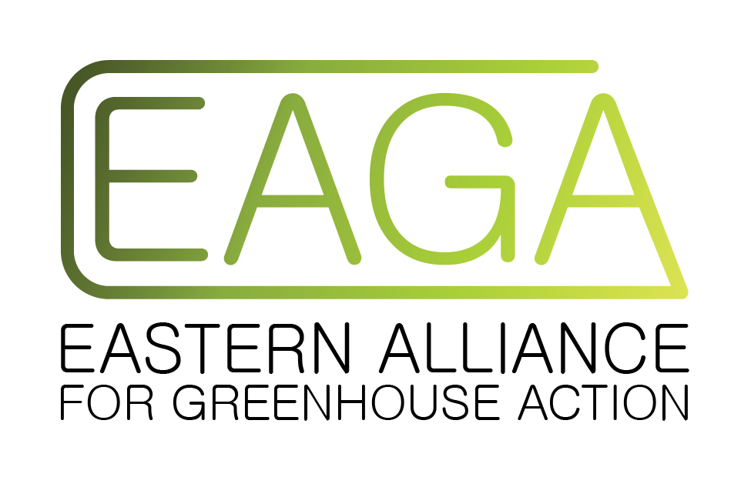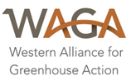

13 July 2020

Hon Angus Taylor MP
Minister for Energy and Emissions Reduction
18 Hill Street
Camden 2570 NSW

Dear Minister Taylor,

Re: Technology Investment Roadmap Discussion Paper May 2020

On behalf of their member councils, the Victorian Greenhouse Alliances would like to raise a number of important issues relating to the Technology Investment Roadmap Discussion Paper (the Roadmap).

The Greenhouse Alliances are formal partnerships of local governments driving climate change action across 70 of Victoria's 79 municipalities. For the past two decades, the Alliances have worked across their networks, communities and partners to deliver regional climate mitigation and adaptation programs. This includes the implementation of joint initiatives that provide economies of scale and enable projects typically beyond the reach of individual councils. Our project work is complemented by targeted advocacy, capacity building activities and regional partnerships.

This submission is informed by our extensive experience delivering energy and climate programs with local governments, communities and industry. It also takes into account consultation with Professor Finkel through the community and environment sector roundtable on 11 June, in which a representative of the Greenhouse Alliances participated.

Overall, we are concerned that the Roadmap does not advance Australia towards addressing climate change with the urgency and magnitude that is required. Although our submission is confined to the scope of the Roadmap we highlight the urgent need for a national climate and energy policy framework. Australia has wasted a decade in which there has been no comprehensive and coordinated national climate action. COVID-19 has demonstrated that the National Cabinet can successfully act on scientific evidence and take decisive action. The same urgency, respect for science, and bipartisanship should now be employed to address the climate emergency. We propose that a national climate and energy policy be included on the National Cabinet agenda..

Please consider the following issues that relate to the Roadmap:

The Roadmap should identify how it is linked to emissions reduction targets
We are very concerned that the Roadmap has no explicit link to the Australian Government’s committed emission reductions targets, let alone any stronger science-based targets, nor any mention of the best way to achieve the required target(s). In fact the Roadmap itself does not mention climate change apart from in the Ministerial foreword. It is our understanding that this process is intended to form the basis of Australia’s long-term low greenhouse gas emission strategy under article 4, paragraph 19 of the Paris Agreement. It is important that further work be done to link the Technology Investment Roadmap and Low Emissions Technology Statements to the context of the global emissions budget for limiting global temperature increase to 1.5°C or well below 2°C above pre-industrial temperatures.

- Technologies should be able to achieve zero emissions

The global emissions budget for limiting average global temperatures to well below 2°C above pre-industrial temperatures is rapidly closing. This means that existing and currently planned fossil fuel developments are sufficient to tip global mean temperatures past that goal. It is critical therefore that Australia seeks to rapidly transition its economy to negative emissions (going beyond net zero emissions).

The report should preclude any technologies that do not provide a rapid pathway to zero emissions. Therefore, technologies and measures such as subsidies designed to expand or even support fossil fuels must, by definition, be explicitly ruled out. These include Carbon Capture and Storage (CCS) associated with electricity infrastructure and gas expansion..

We are deeply concerned that the ‘neutrality’ of the technology roadmap is compromised by the massive gas subsidies proposed by Manufacturing Taskforce of the National COVID Coordination Commission (NCCC). These gas subsidies will dwarf any past subsidies provided to renewable energy and erase any emission reductions that might be made possible by the technology roadmap. The decisions to expand fossil fuels under the cover of COVID-19 economic recovery are deeply concerning and run counter to any intention to address greenhouse gas emissions. It is also at complete odds with goals of councils and their communities across Australia, who are increasingly making ‘climate emergency’ declarations, setting ambitious science-based zero net emission goals and implementing them through their own technology roadmaps, which involve switching to renewable energy, efficiency and energy demand management. One significant trend is the electrification of energy requirements in order to move away from gas as a polluting fossil fuel. As well as avoiding emissions, councils are concerned not to make investment decisions which lock them into emissions-intensive infrastructure which may prove wastefully expensive over its lifespan, as gas markets change and renewable energy advances.
Accordingly, whilst we acknowledge that existing gas may have a short term role in assisting higher penetrations of wind and solar, there is no medium to long term role for gas. Open-cycle gas is very flexible but quite inefficient. While newer open-cycle gas turbines can be better, the worst open cycle gas power station in Australia (Dry Creek in SA) emits more greenhouse gas per unit of electricity than the very worst coal fired power station (Yallourn).
- The Roadmap should set an overarching goal for electrification and efficiency

It is broadly recognised that Australia can achieve a zero emissions economy by electrifying all sectors. Professor Finkel also laid out a vision for an ‘electric planet’ in his press club briefing on 20 February 2020. This recognises “a future where we supply the vast majority of our energy requirements by electricity. Clean electricity.” However, the Roadmap does not currently identify any overarching goals of electrification. This mustguide the priority statements.

Incorporating low emissions technologies in transport and industrial sectors requires switching from fossil fuels to other energy sources. As Australia’s electricity grid becomes cleaner transitioning from other fuels to electricity, will make even more economic sense. For example switching from petrol to electric vehicles, could save Australians $400bn in imported oil between now and 2050 according to University of Technology Sydney.
Local governments are working to ‘get off gas’ for their own facilities and support industry, manufacturing and agriculture to do the same. This includes the electrification of industries and businesses that require heat and steam. Thereis a huge opportunity in Australia to advance heat pump and other gas and diesel replacement technologies as well as demand response. Similarly, councils are working with communities to support energy efficiency including shifts to all electric homes and electric transport.

- Immediate need to rapidly advance wind and solar

The Roadmap recognises the role that wind and solar are playing, and admits that they are foundational and already commercial. However, the Integrated System Plan recognises the need to significantly grow wind and solar generation over the next two decades to address the closure of coal plants. The growth of large scale wind and solar requires ongoing government action to unlock its potential.

Modelling by the University of New South Wales suggests that wind generation could supply up to 70% of Australia’s electricity needs, while modelling by CSIRO and Energy Networks Australia found that wind and solar could provide nearly all generation in future. UNSW’s analysis, backed up by AEMO’s Integrated System Plan, also found that many of the best solar and wind sites in Australia were in remote locations – renewable energy zones, needing new transmission investments to harvest these amazing resources.

As such it is critical that transmission grid upgrades in the Renewable Energy Zones (REZ) are accelerated in the short term. For example, there is currently 4000MW of solar and wind in the pipeline (2000MW with planning approvals and 2000MW in earlier stages) for North West Victoria yet the grid capacity is already constrained. However, these upgrades are not expected to occur until late 2020s. Grid upgrades should potentially be considered as part of broader ‘enabling technologies’ that help to accelerate renewables.

Goals should be set in the short and medium term to foster greater penetration of large scale wind and solar. It cannot be assumed that the record levels of investment that have occurred in the past 5 years will continue.

- Improvements to the prioritisation framework

We understand the prioritisation framework that will be used to set the technology priorities in the annual statements. However what is is not clear are the weightings that each criteria, such as abatement potential, receives compared to another criteria.

In addition to the criteria already identified in the Roadmap, we suggest further consideration of cost curves of different technologies, noting that some are forecast to dramatically reduce in coming years, especially with public investments in R&D. Another element should be focused on investability, noting that global markets and insurance companies are moving away from fossil fuels including gas and Carbon Capture and Storage (i.e. anything that is not zero emissions). This will in turn help to ensure that technologies are not supported which may become stranded assets in the next decade or two.

Continue support for the Clean Energy Finance Corporation (CEFC) and the Australian Renewable Energy Agency (ARENA)

The Australian Renewable Energy Agency (ARENA) and the Clean Energy Finance Corporation (CEFC) have achieved significant returns on investment for Australia. We consider that these agencies are best placed to support the ongoing energy transition and should continue to be supported.

We support expanding ARENA’s remit to include energy efficiency and clean transport, clean industrial technologies. We do not support their remit being revised towards ‘end of pipe’ solutions for fossil fuel-based industries, such as Carbon Capture and Storage. Any further investment in emission-intensive industries will only marry further generations to stranded assets and lock consumers into dysfunctional markets.

Stretch goal of 700% renewable energy

The Roadmap has requested submissions that relate to ‘stretch goals’ of higher ambition. Australia has a unique opportunity to become a significant global exporter of renewable energy. We consider that a stretch goal of 700% renewable energy should be built into the Roadmap. Whilst this is high, it is not unrealistic, given the economic as well as environmental opportunity for Australia, which is why it is supported by experts such as Darren Miller, CEO of ARENA. With the necessary policy drivers in places, the renewable energy industry has proven it is capable of meeting ambitious development targets

WWF have recently released a report titled “Making Australia a Renewable Export Powerhouse”. It recognises Australia’s enormous export potential particularly in the following areas where Australia has a comparative advantage:
    - Renewable ammonia
    - Green steel
    - Batteries
    - Knowledge/expertise in the transition
    - Aluminium
    - Technology/software for things like microgrids, DSR

A fully costed renewable exports plan should be developed as a priority.

Supporting jobs and training

Realising Australia’s zero emissions future will require new jobs and new skills. A recent report released by the Clean Energy Council demonstrates the opportunity from tripling large scale wind and solar. The report identifies that such an ambition could deliver >50,000 direct construction jobs and 4000 ongoing jobs, inject $50 billion into the Australian economy and significantly benefit regional Australia. Similarly, Beyond Zero Emissions have recently released their 1 million jobs plan, which also identifies the significant levels of economic benefits and employment opportunities from boosting investment in renewable energy.
To support this, it is critical that the training sector is ready to support these future jobs. This may involve engaging with the business sector to identify opportunities for training and skills development, and raising awareness about the skills and capabilities the industry requires. Industry associations may be able to promote open tenders and opportunities to supply services to projects when they are announced, as well as liaise with developers to identify project needs and communicate these to local suppliers.

Thank you for the opportunity to make a submission to the Low Emissions Technology Roadmap Discussion Paper.
If you have any questions or queries relating to this letter, please contact:

Rob Law, Executive Officer, Central Victorian Greenhouse Alliance (CVGA) | email eo@cvga.org.au

Scott McKenry, Executive Officer, Eastern Alliance for Greenhouse Action (EAGA) | email scott.mckenry@maroondah.vic.gov.au

Bronwyn Chapman, Executive Officer, Goulburn Broken Greenhouse Alliance (GBGA) | email eo@gbga.com.au

Dominique La Fontaine, Executive Officer, South East Councils Climate Change Alliance (SECCA) | email dlafontaine@secca.org.au

David Meiklejohn, Executive Officer, Northern Alliance for Greenhouse Action (NAGA) | email david@naga.org.au

Fran MacDonald, Executive Officer, Western Alliance for Greenhouse Action (WAGA) | email franm@brimbank.vic.gov.au

Ian Southall, Executive Officer, Gippsland Climate Change Network (GCCN) | email ecohub1951@gmail.com

https://www.abc.net.au/news/2020-05-21/leaked-national-covid-commission-gas-manufacturing-report/12269100

